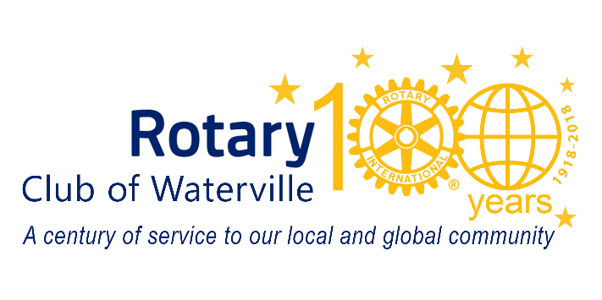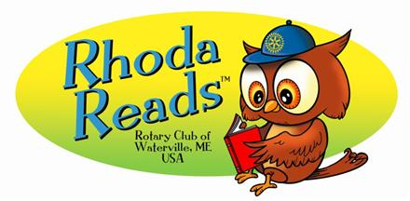

Rhoda’s Rescue Order Form

Rhoda’s Rescue, written by Maine author Barbara Walsh, and illustrated by Abby Grieg, is dedicated to children who love to learn and read, and to community members who volunteer for the betterment of all.

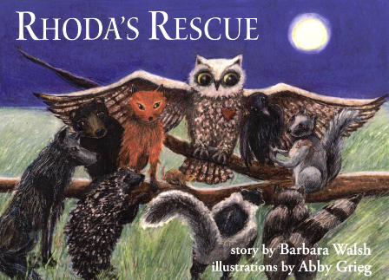 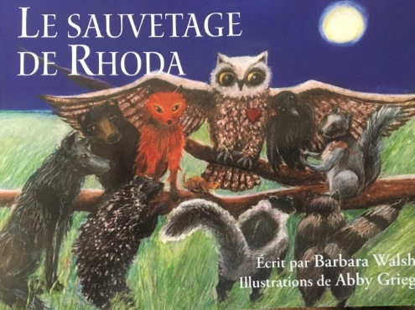 

*“In the tallest tree in the forest, in a cozy crook of a branch, lived a wise owl named Rhoda. She had big yellow eyes that glowed in the dark and could spot even the smallest creature scurrying along the woodland floor. With her special owl ears, she could hear the tiniest twig snap or the softest squeal of a miniature mouse”.*

|  |  |  |  |
| --- | --- | --- | --- |
| Qty | Title | Price | Total $ Due |
|  | Rhoda’s Rescue (English) | $14.95 USD or $30.00 CAN | $ |
|  | Le sauvetage de Rhoda (French/Français) | “ | $ |
|  | El rescate de Rhoda (Spanish/Español | “ | $ |
|  | *Total amount due (not including shipping charges - billed later)* | | $ |

|  |  |  |  |
| --- | --- | --- | --- |
| √ | Payment | |  |
|  | Check enclosed, made payable to Rotary Club of Waterville | |  |
|  | Credit Card # | Exp | CVV Code |
|  | Signature | | |

|  |  |
| --- | --- |
| Ordered By |  |
| Club Name | District # |
| Contact Person | |
| Shipping Address | |
| Phone including area code | Email |

Rotary Club of Waterville, ME USA

PO Box 192

Waterville, ME 04903-0192

www.watervillerotary.com

RhodaReads@gmail.com