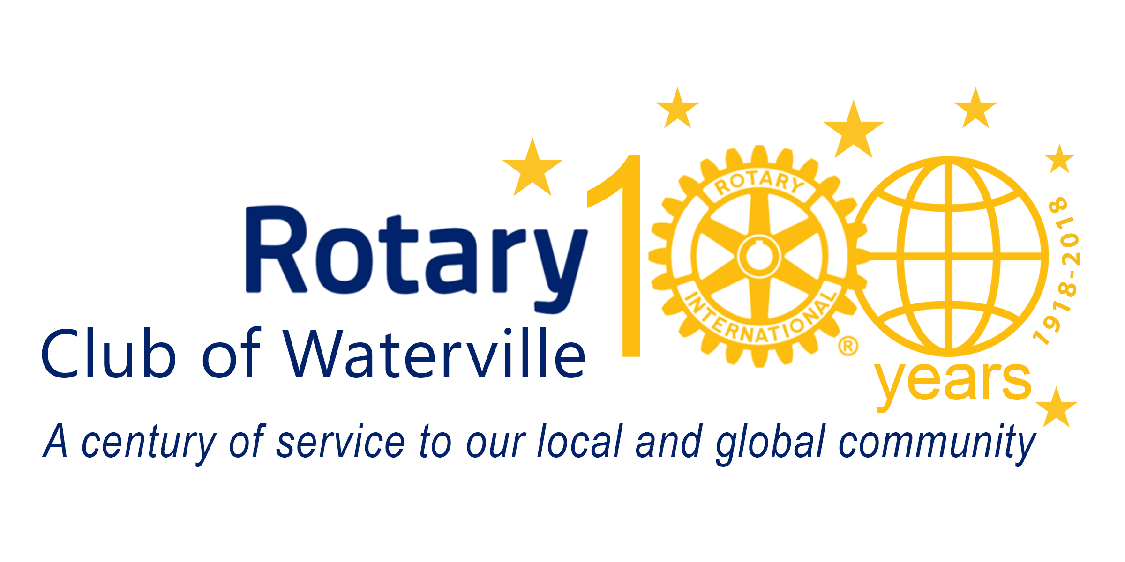
Board Meeting Minutes
October 20, 2021
- Call to order
Jeff M. called to order the regular meeting of the Rotary Club of Waterville Board at 3:05 PM on Thursday, October 20, 2021 at Mid-Maine Chamber of Commerce and via Zoom. A quorum was present.

- Roll call – 8 needed for quorum
 | Bob Barton
 | Christine Black |  | Present
 | Maggie Bryant
 | Tina Chapman, Secretary |  | Present
 | John Dalton, President Elect |  | Present
 | Dan Eccher, Vice President |  | Present
 | Peter Garrett |  | Present
 | Christopher Gaunce |  | Present
 | Jeff Jolicoeur
 | Kim Lindlof |  | Present
 | Tom Longstaff |  | Present
 | Jeff Melanson, President |  | Present
 | Erin Merrill |  | Present
 | Suzanne Uhl-Melanson
 | Sarah Wadick, Treasurer
III.  IV.  V.  VI. |  | Secretary Report:  Tina presented the minutes of the September 2021 board meeting. Peter requested that under the International Services section that the last sentence be changed to read “as details of global grant applications are changing significantly”. Tina will make that change. Peter made a motion to accept the minutes as presented, Dan seconded. All in favor. Tina shared our current membership numbers – we have 47 active, 4 active/corporate and 4 honorary for a total of 55. We also have 9 people on our corporate/ancillary member list.  Committee Reports:  Club Administration:  Erin has been busy managing the speaker schedule, she is booking out to the beginning of January and has plenty of leads. We will have a special speaker on December 20th, but we are not releasing the name publicly so as to not have the press want to attend. Kim noted that we need more people to help out with Sargent of Arms duties.  Treasurer’s Report:  Sarah sent along with financials for review. We will table discussion until next month.  Membership:  John noted that 8 members are currently in arrears with dues – he plans to reach out to these folks. Jeff shared that he and Peter both picked up some potential new member leads at the Chamber B2B, so we now have a total of 9 leads. We also picked up 4 auction donors and two speakers as well as raising $205 for Polio.  Michael Elliott from WorkHealth has left the club, he has taken on a different position. He is helping to find a replacement from WorkHealth to join the club in his place.  We have a new member application from Matthew Hunt which John will send out to the Board for a vote.  John is looking to do new member inductions. He does have some concerns about the lack of engagement from some of our affiliate corporate members and he has actively been trying to connect with them. We do have a new corporate member application from United Way of Kennebec Valley for Katelyn Pushard and Courtney Yeager.  Community Service:  Christine had sent along notes from her most recent committee meeting – highlights are as follows:  - Use of Auction Funds for Food Security:  The committee will be using the same grant application process as last year to award funding after the online auction is completed. They will reach out to the list of non-profits that applied last year, as well as non-profits that did not apply but are likely eligible.  - Little Free Library:  Michael and Christine have painted the library. Plexi glass doors and hardware will be purchased and shingles will be placed on roof. Each committee member will take a month to make sure books are stocked. They are looking at adding Rotary branding in the form of stickers.  - Born to Learn Trail:  Christine will connect with Matt from Parks & Rec. The project will likely need to be completed in the spring as the project is weather dependent.  International Service:  No new updates.  Vocational & Youth Service:  No new updates.  Foundation:  The Polio fundraiser and fellowship event is this Sunday. Tom reported that for Foundation Month in November, each week his committee will highlight local and global efforts made possible through the Rotary Foundation, as well as encouraging Rotarian participation in EREY.  Ways & Means:  Suzanne sent along an update. Save-the-Date cards were distributed to Rotarians, other Rotary Clubs (Augusta, Sunrise, Skowhegan, Unity and Farmington) and also distributed at the B2B show and to area businesses. Our first major in person fellowship event will be Thursday, November 11 from 5:30-8PM at Central Maine Motors. This will be a pot-luck. Also, everyone should be encouraging their friends and family to register on Bidding Owl to check out all the auction items and gift certificates.  Public Relations & Marketing:  Ken Vlodek has offered to take on posting for the Club on Facebook and will focus on the auction.  New Business:  By-Laws  No updates to report this month.  Draft Budget Review  The budgets were reviewed. It was suggested that we remove Mid-Maine Global Forum. Peter will reach out to them. Jeff M. requested that board members send any other questions or comments by e-mail.  Sister Club Proposal  Tabled until next meeting.  November Invoicing  Tabled until next meeting.  Club Archive Storage  Tabled until next meeting.  Rotarian of the Month  Please send suggestions to Jeff.  Adjourn:  The meeting adjourned at 4:00 PM.

